1.First of all I transformed Product Information (Excel File) into CSV file extension through save as, just in case it does not create trouble while ETL process as

**Both extensions were different:(Before that I open those files in excel just to be sure that data does not have any duplicate values,

However, those files don’t contain any duplicate values)

2.Then I open the Power query editor in power bi.

3.In power query editor I open the files Sales Data (CSV Files) and Product Information (CSV File) and starts to transform in same manner as required:

4. As Sales Data (CSV Files): sales_jan.csv, sales_feb.csv, sales_mar.csv have the same columns with same data type, used append queries in power query editor to merge them into a single table and named it as "Main table".

5. Then removed columns Customer Type, Return Status as it was unnecessary to load into main table.

6. Then to load "Product Name" & "Category " from product table into main used "Merge Queries" as in both product and main table there is

a common column name Product Id on its basis , I've left join and merged.

7.After tables got joined then I fetched the Particular columns "Product Name" ,"Category " which are necessary and move it before the date column.

8. Then also removed the product id column.

9. Now, to add the new calculated column "Net Revenue" I've followed the steps,

Add Column>>Custom Column>> named it as "Net Revenue" and in formula bar "= ([Sale Amount]- [Discount]) * [Quantity])"

TBC.

10. Now, to add the new calculated column "High Value Sale" I've followed the steps,

Add Column>> Conditional columns>>Then named the column and insert the necessary values ,("If Net Revenue > 3000 then "Yes" else "No") .

Formula= "(Table.AddColumn(#"Removed Columns1", "High Value Sale", each if [Net Revenue] > 3000 then "Yes" else "No"))"  
  
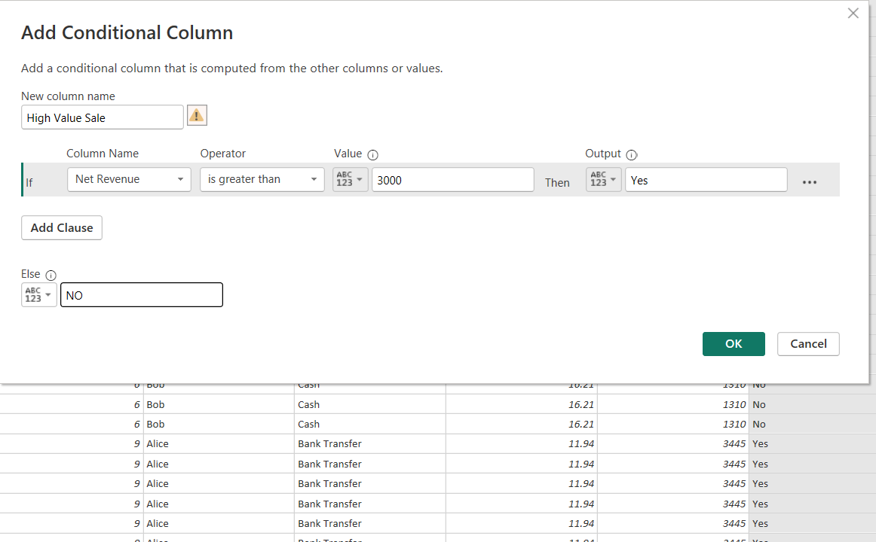

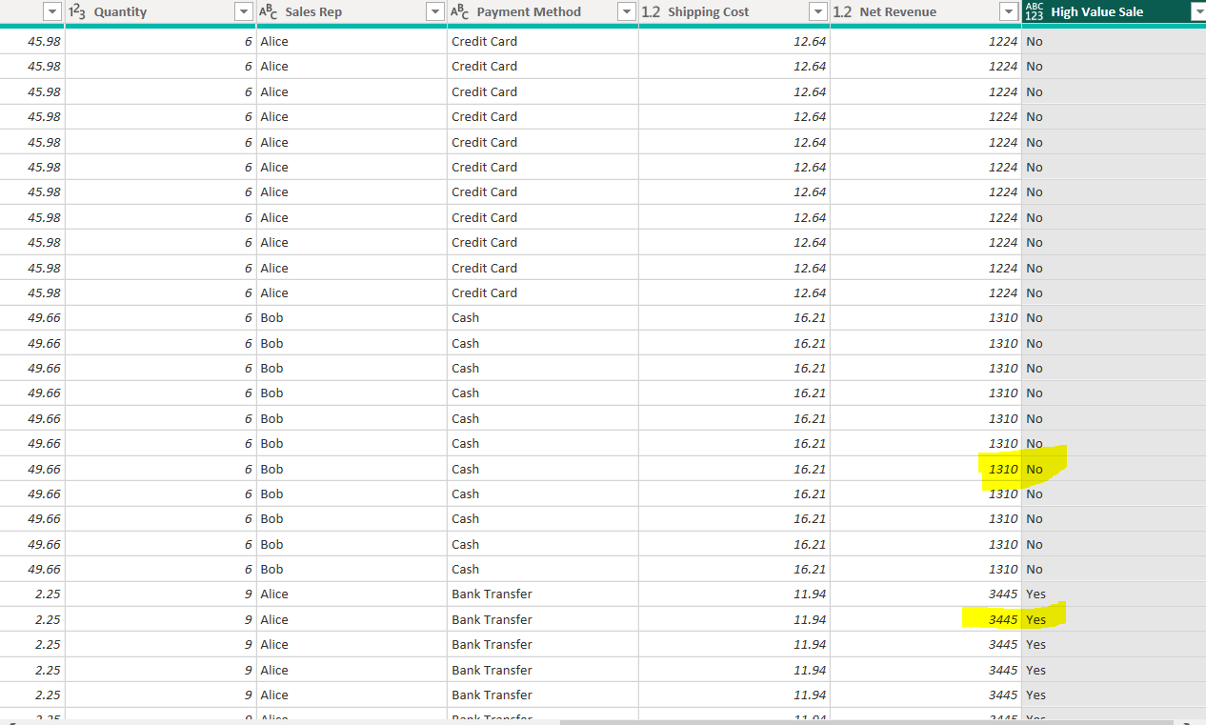

Thank You.